Asynchronous Agent Service

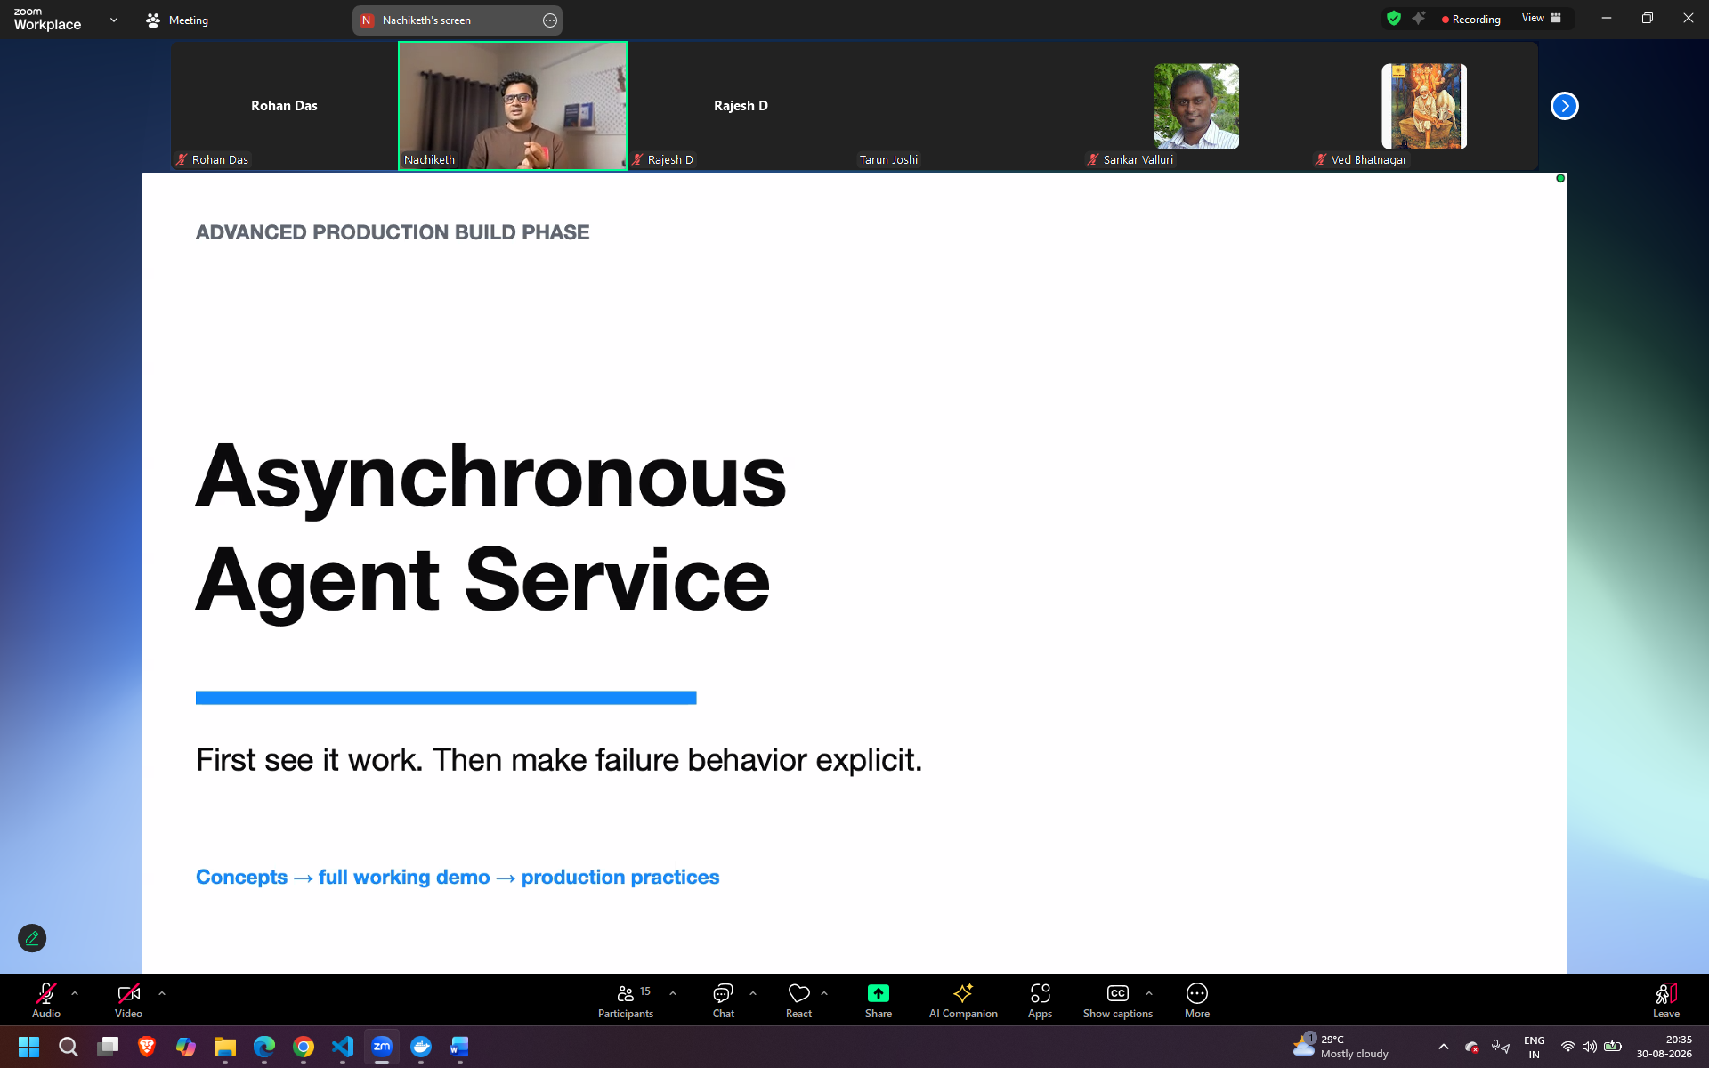
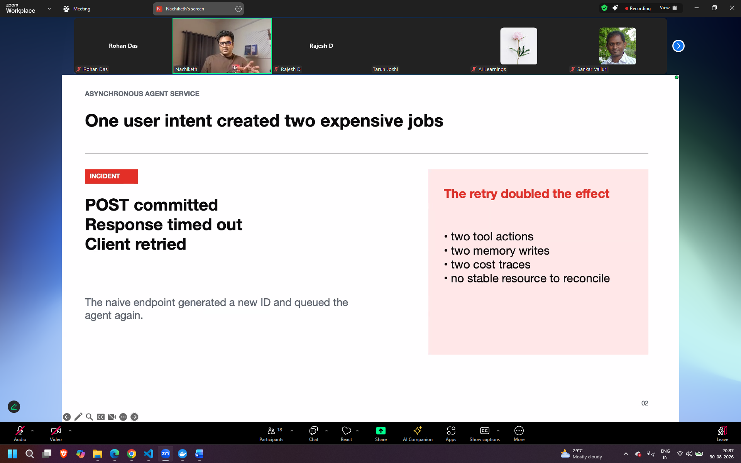
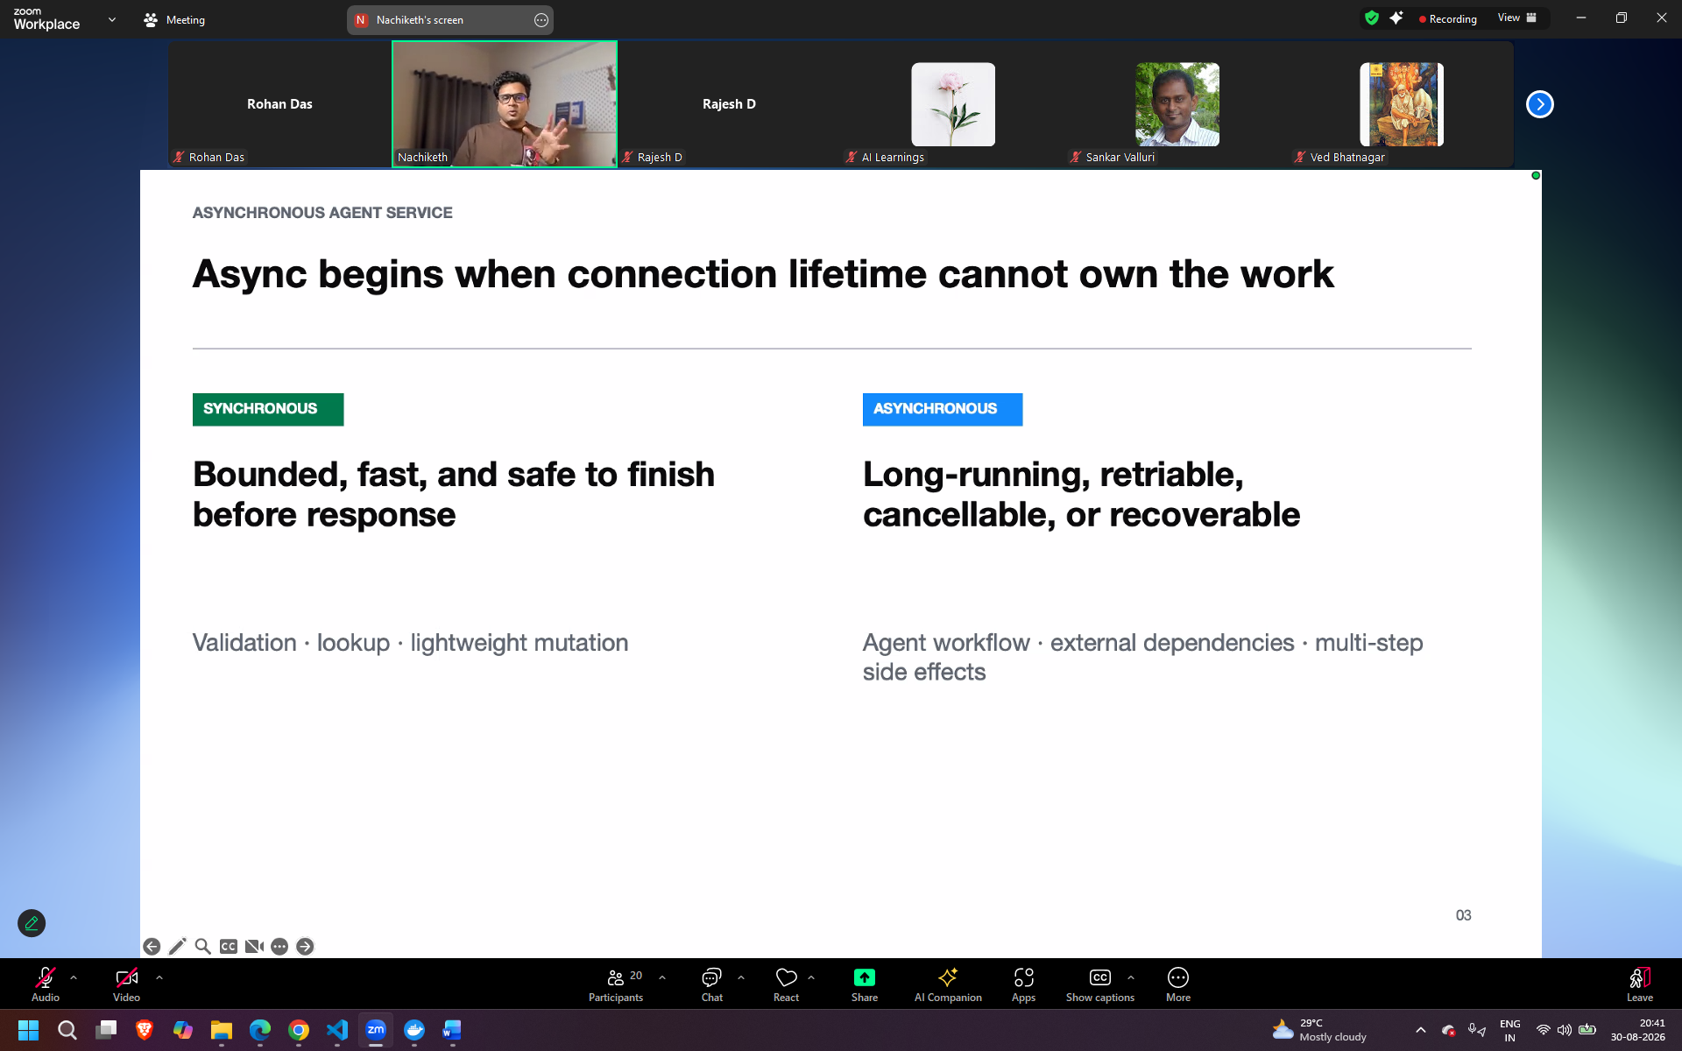
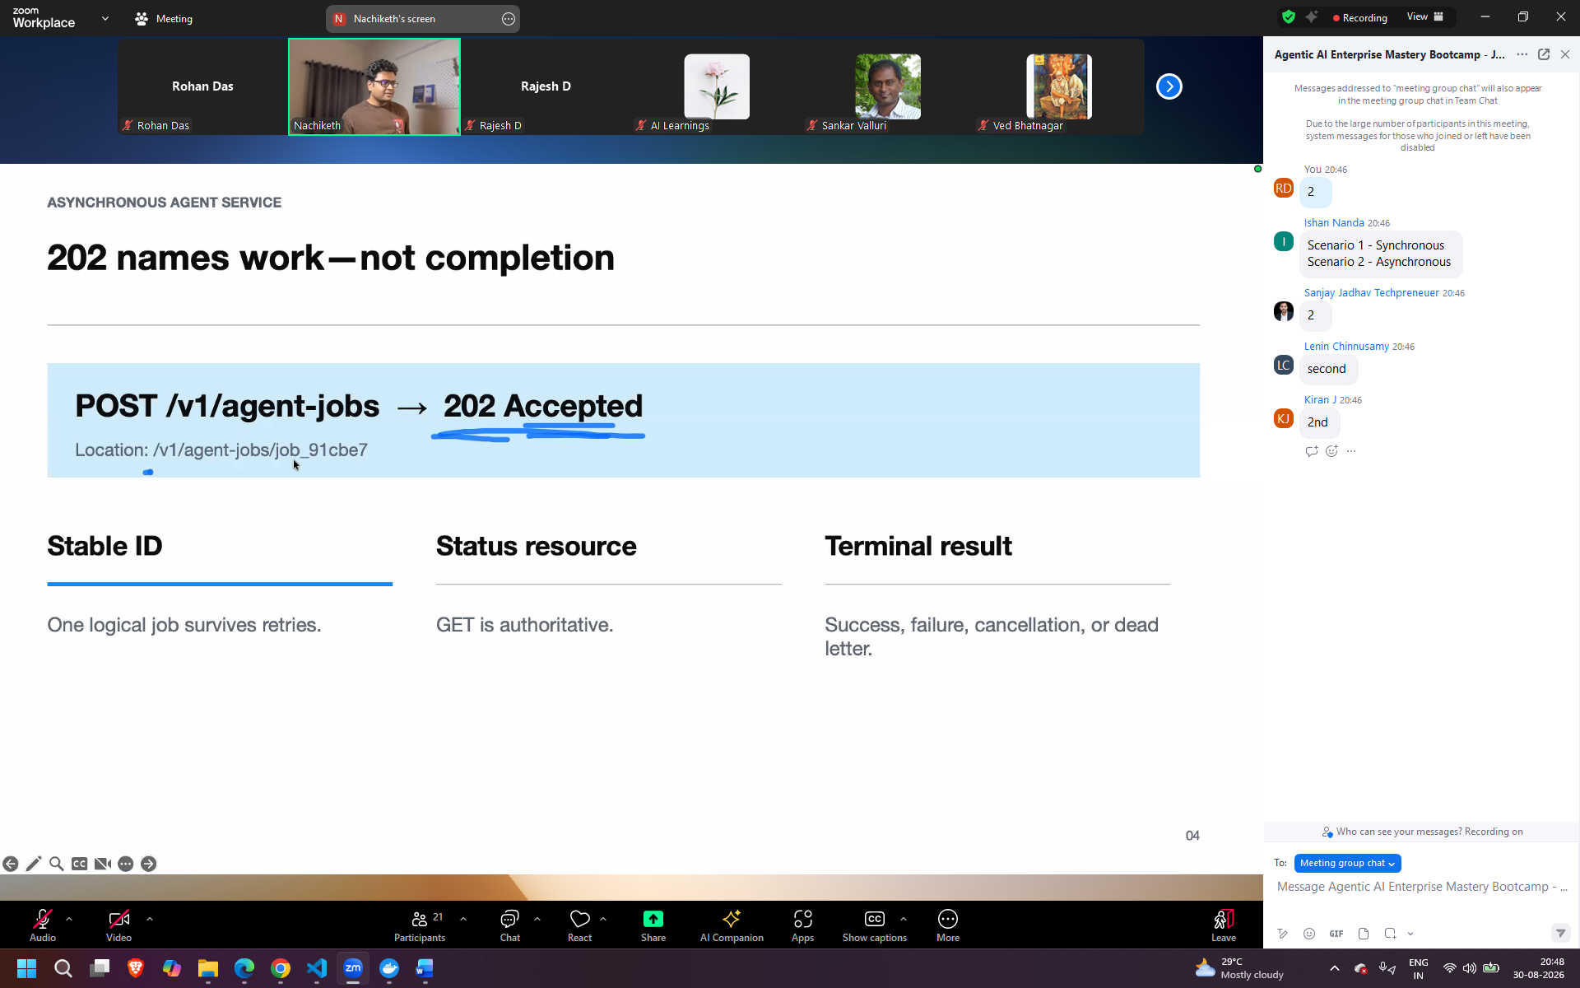
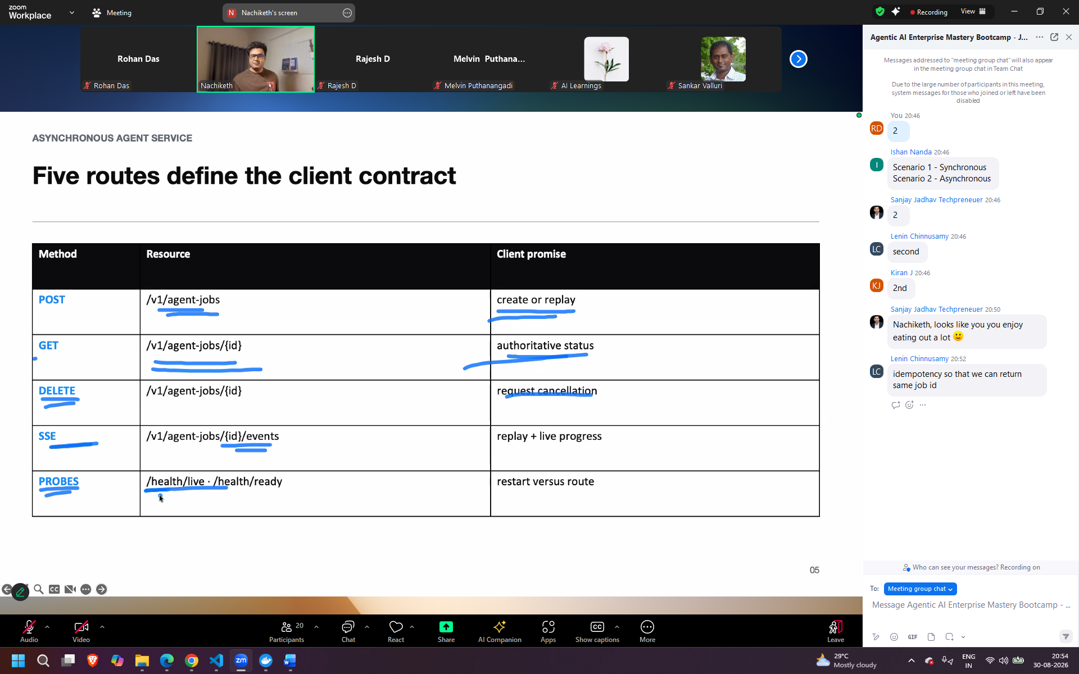
SSE - progress
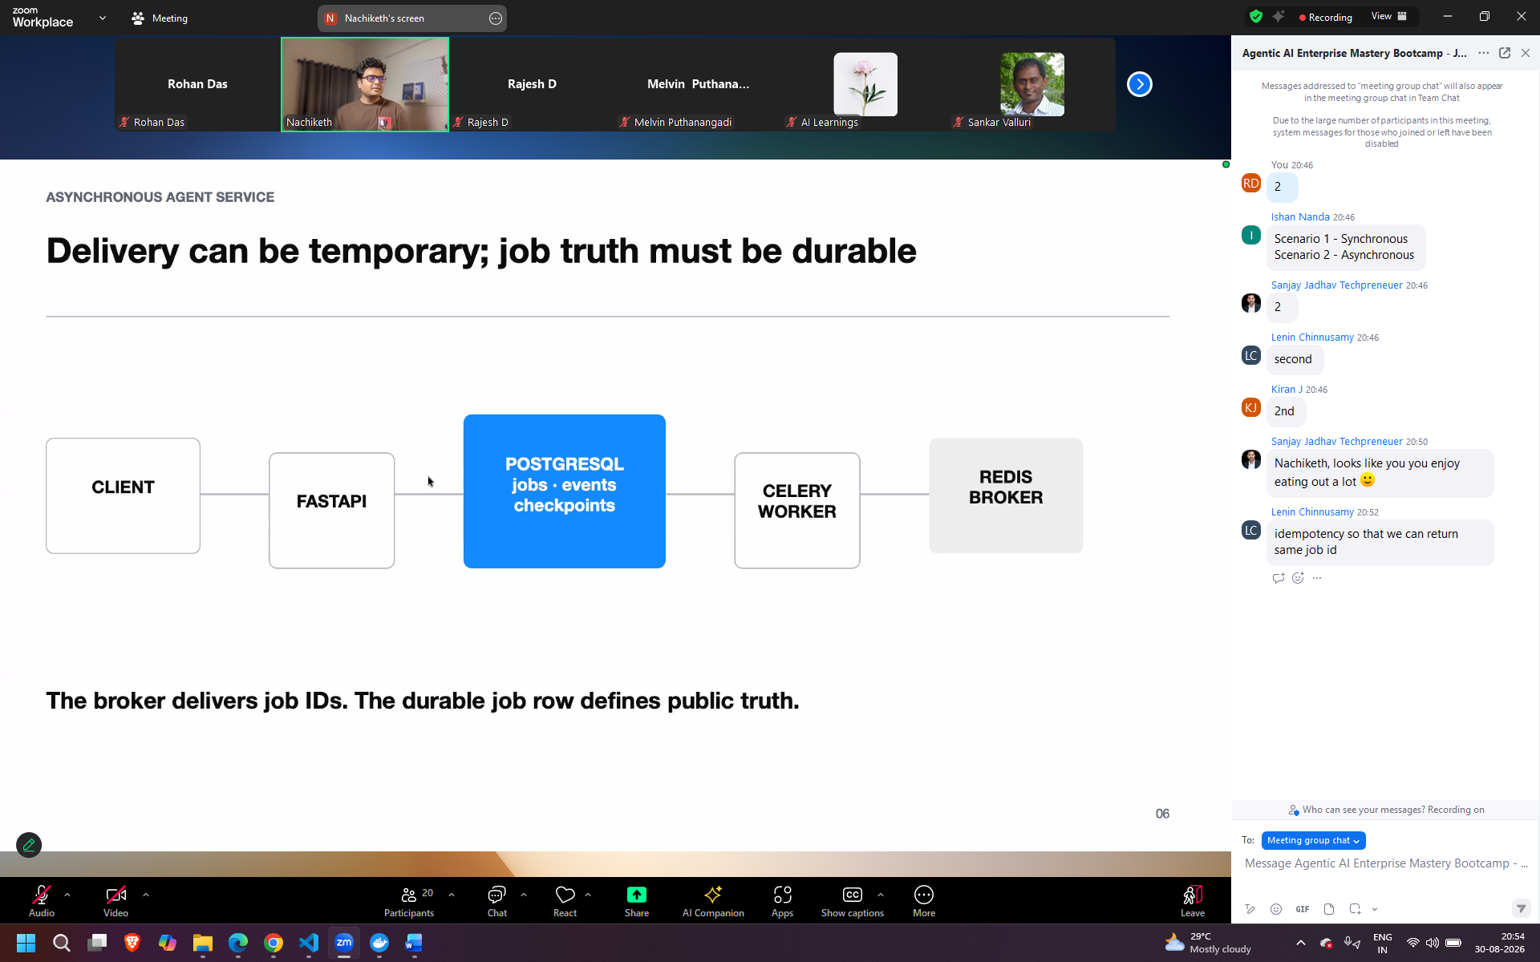
Fastpai(exposed out agentic application) – first have the http contract
Postgress sql – store my durable truth (jobs, status, event history, checkpiunt, goverened memory
Celery worker – run my agent steps
Redis – have the latest status
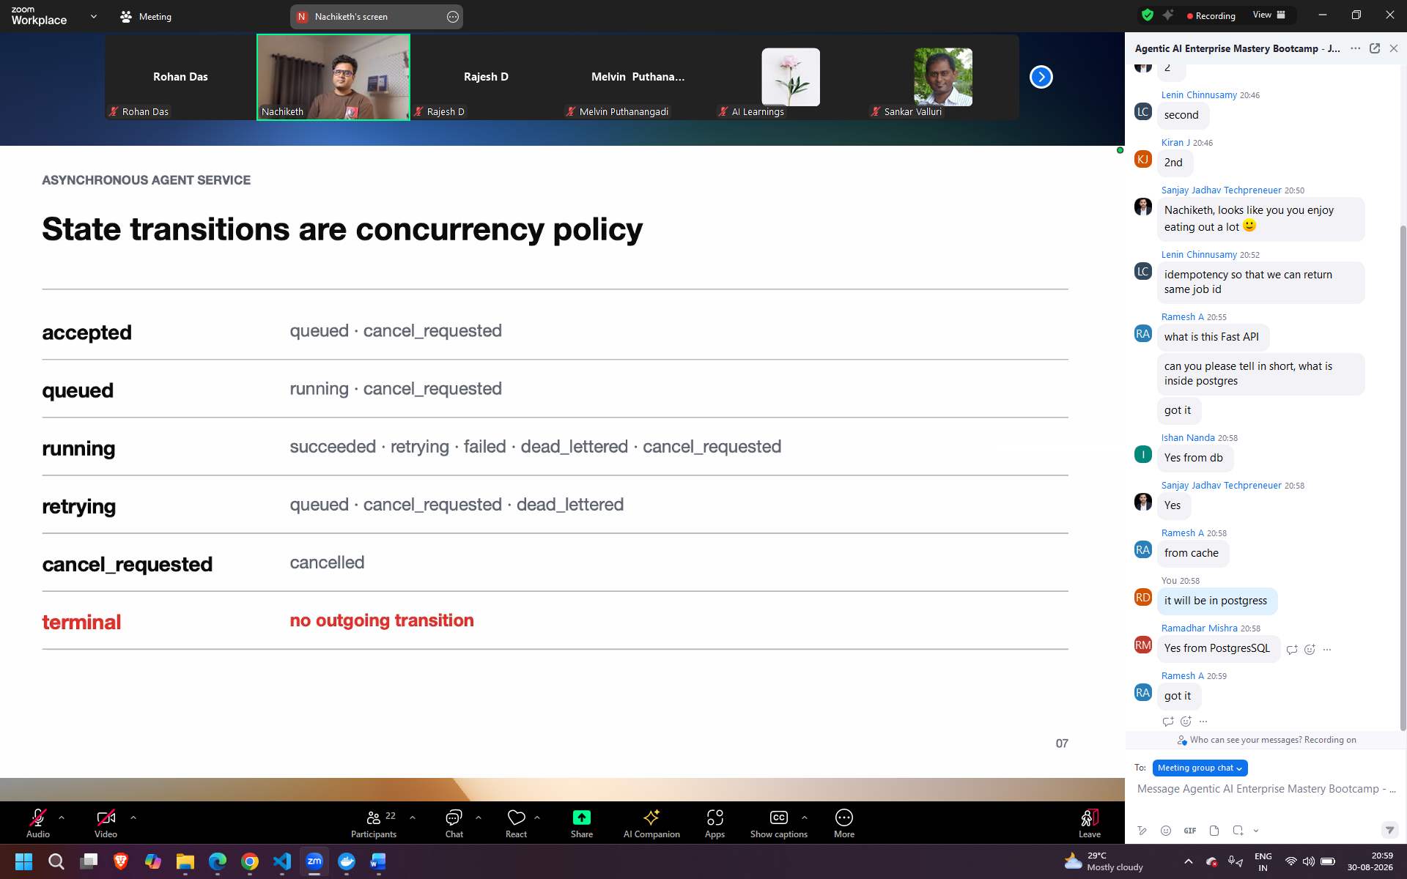

App folder api.py – creating endpoints or job creation
Service.py – reply of the job
In api.py verified_auth – in real prod jwt auth or any other authentication will take place
Store.py – storing in postgress
In sql/schema.sql – schema of the tables where jobs status will be saved

Complete flow 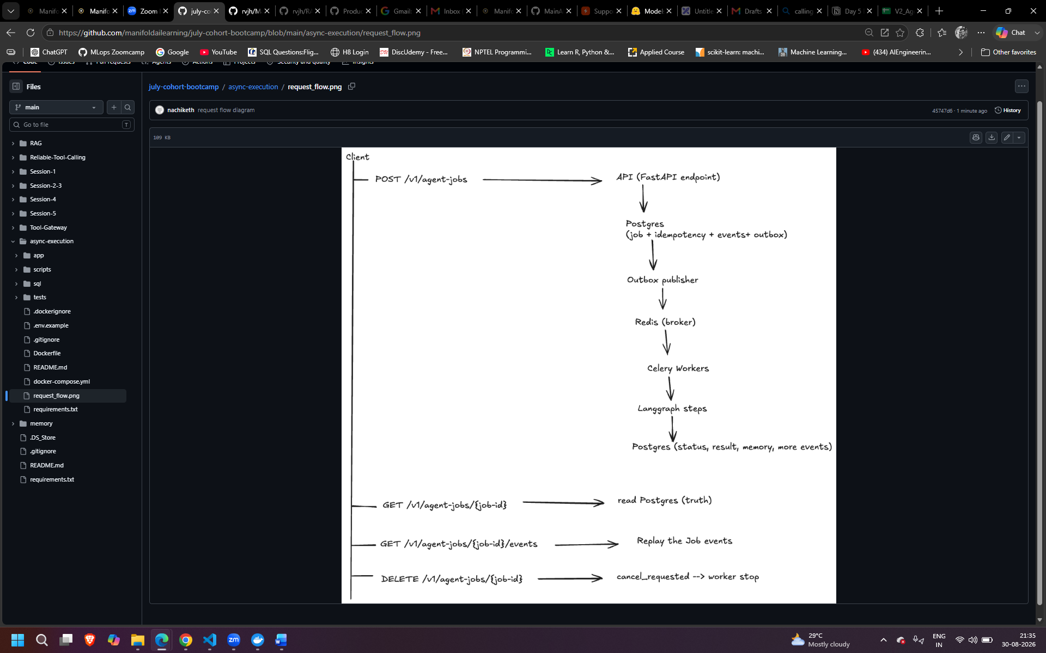

http://localhost:8000/docs
docker compose up --build
curl -s http://localhost:8000/health/live
curl -s http://localhost:8000/health/ready
python scripts/demo_full_flow.py

go inside the async folder
step by step
step 1
run docker compose up --build
first time time consuming
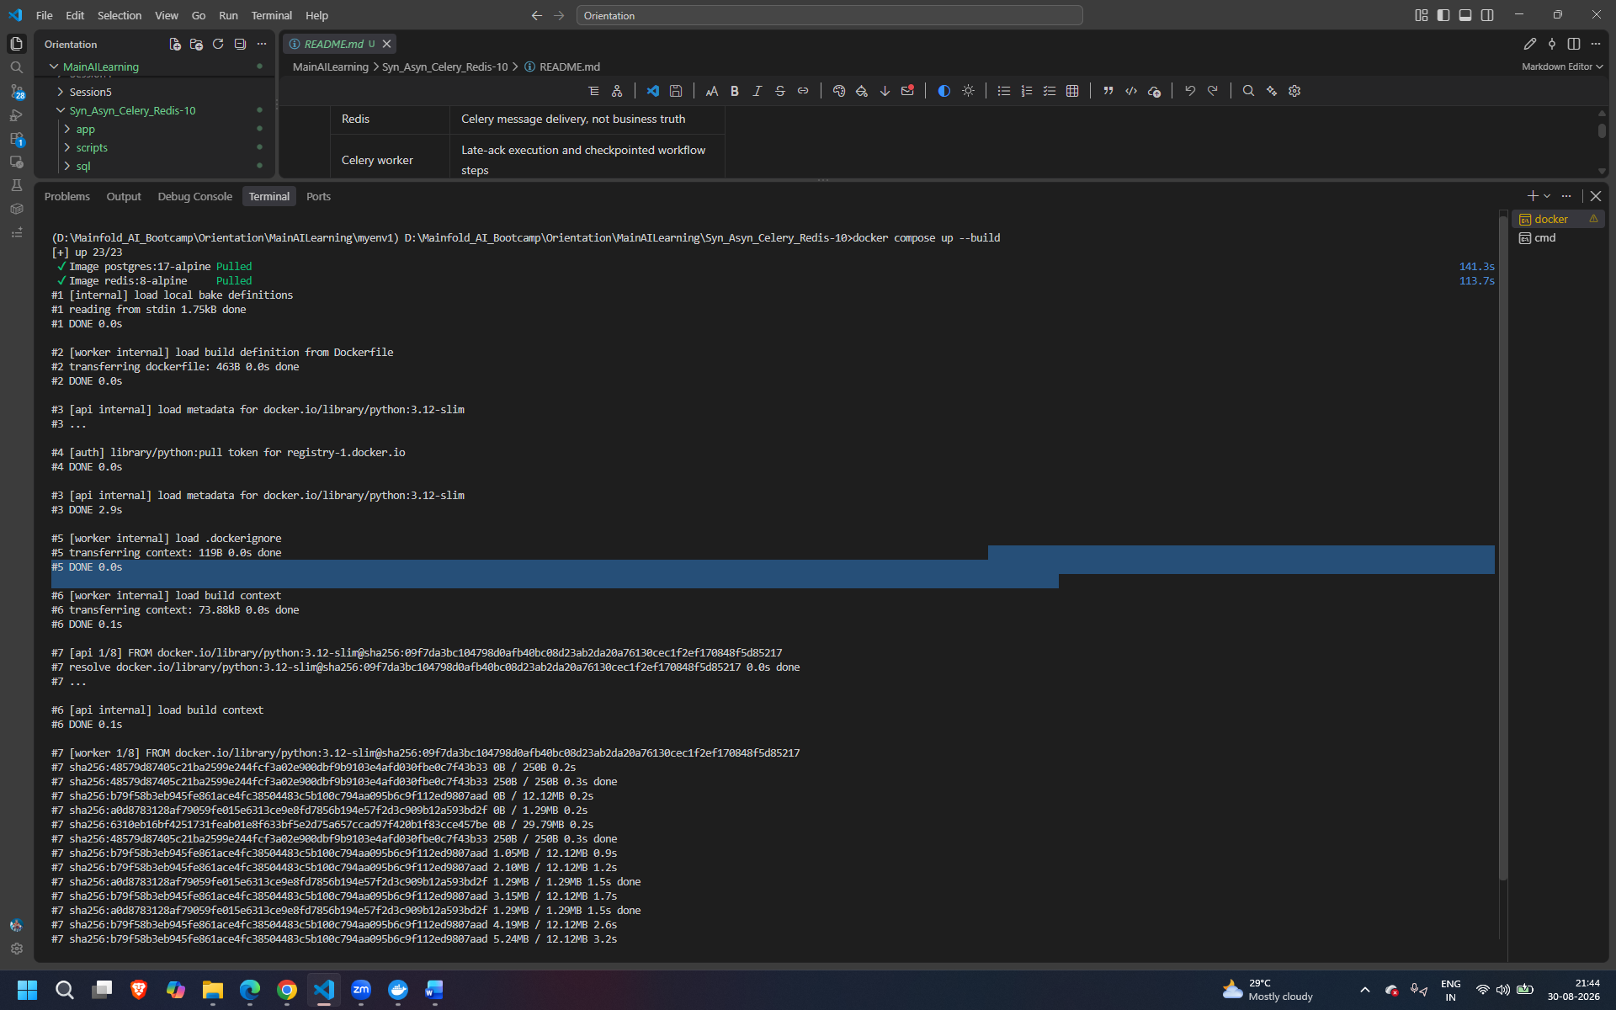
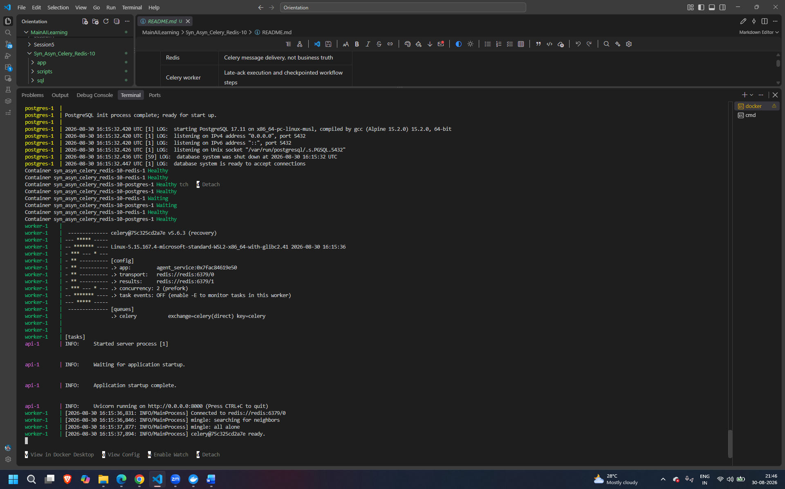
Step 2
Run the below from another terminal into same folder
curl -s http://localhost:8000/health/live

200 response in docker terminal
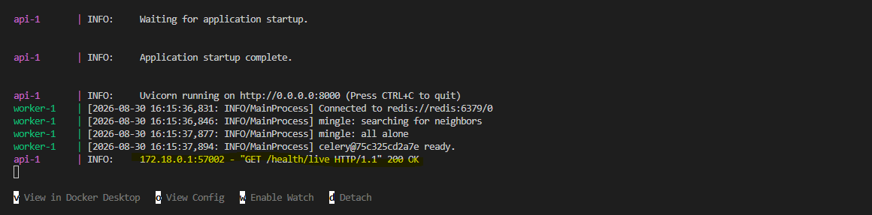
Step 3
Run curl -s http://localhost:8000/health/ready
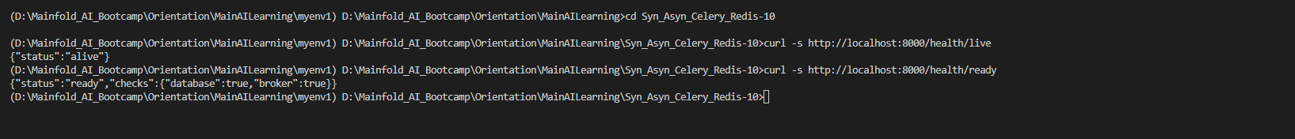
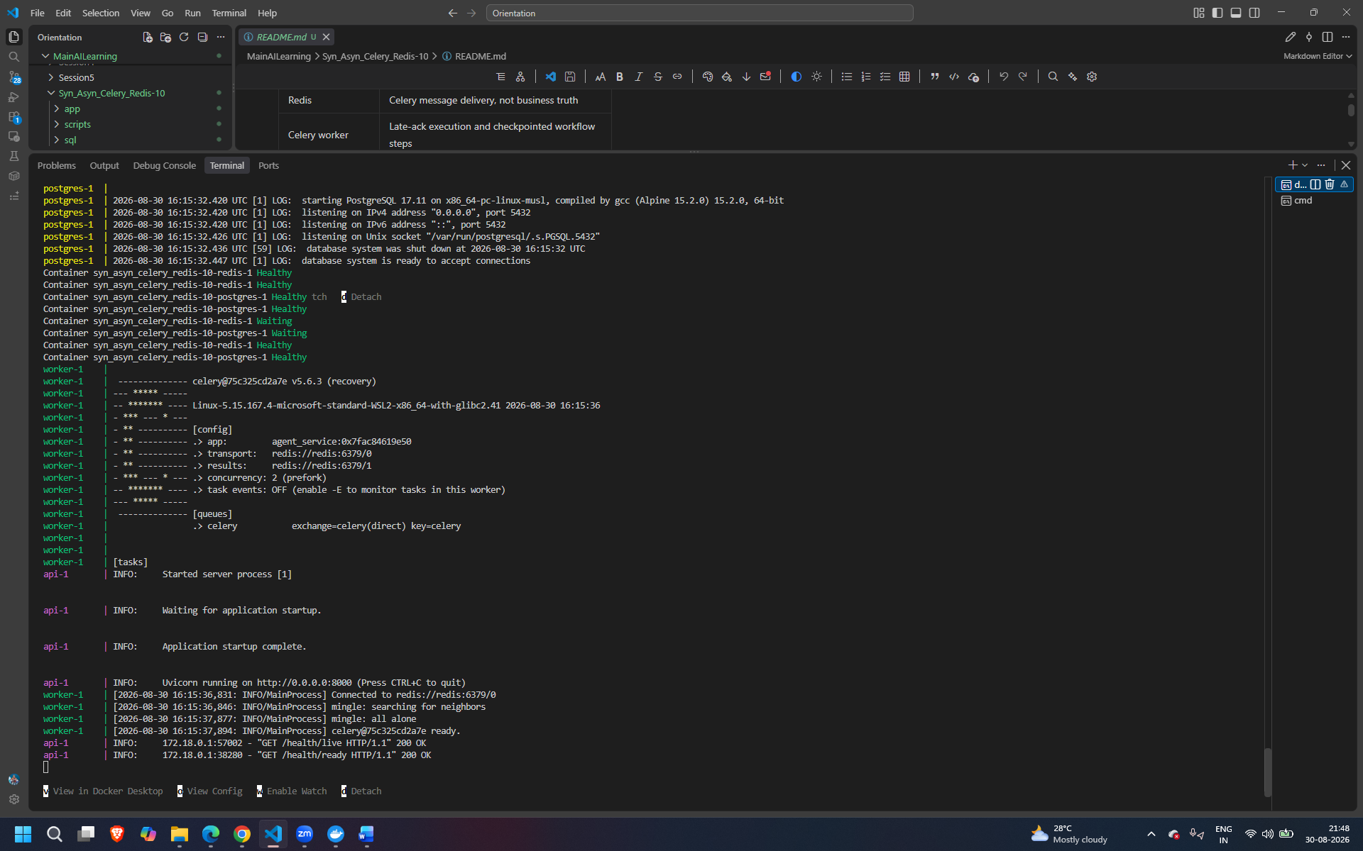
Step 4
Run python scripts/demo_full_flow.py
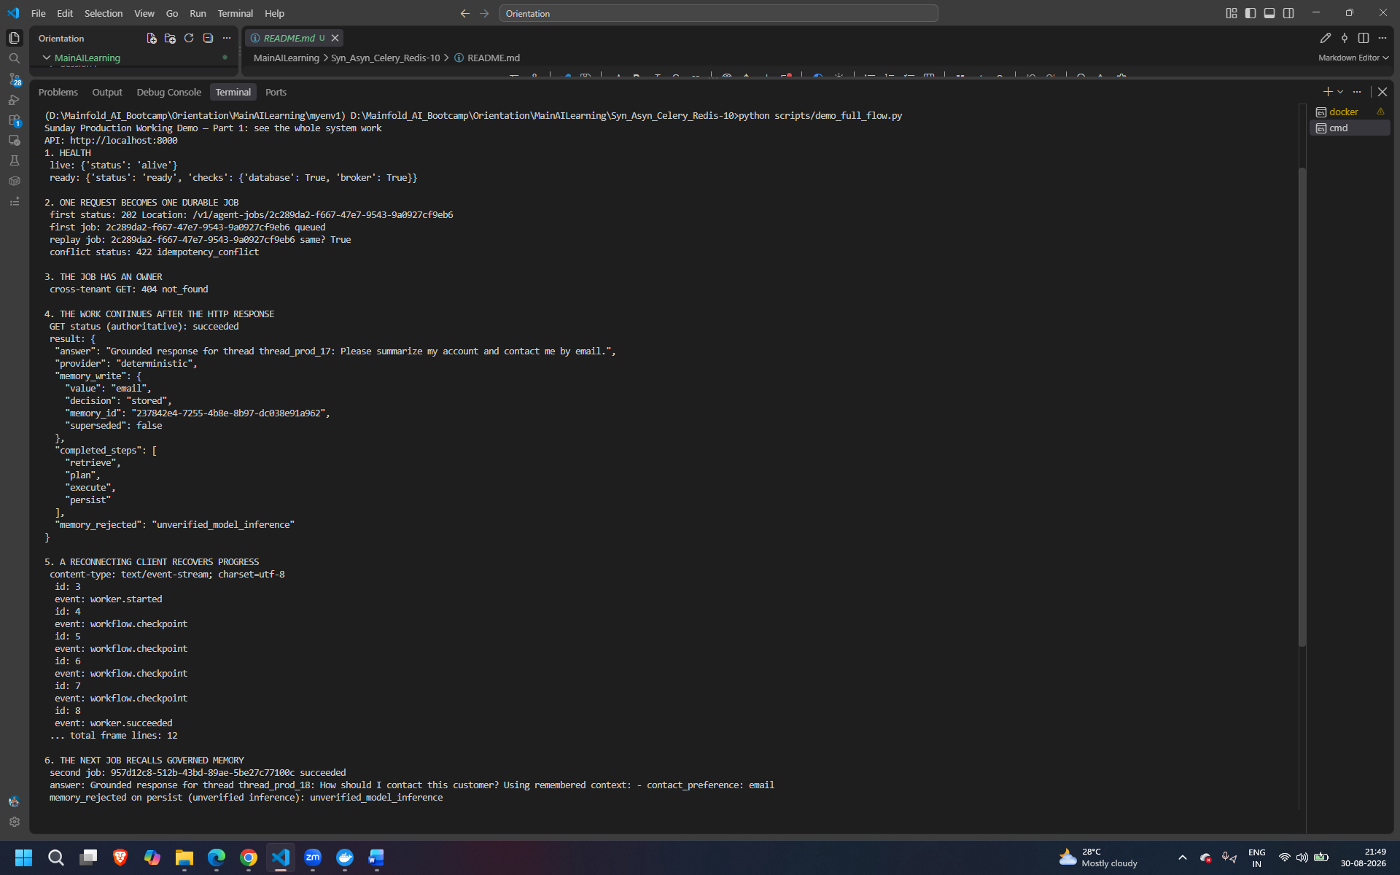
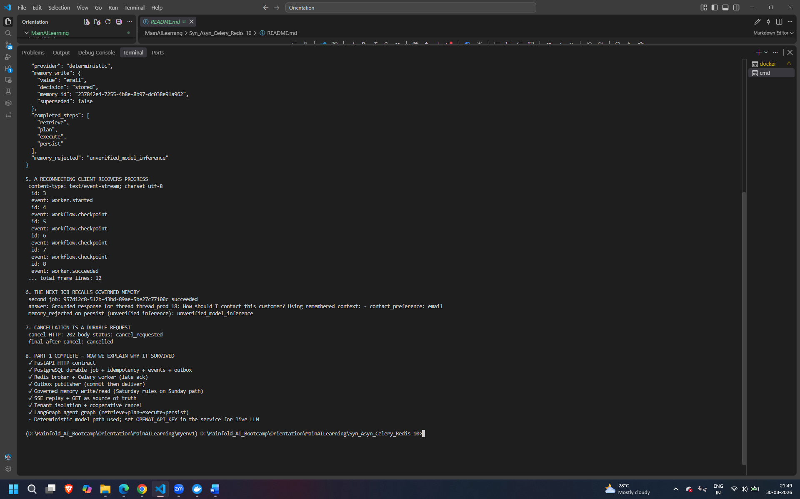
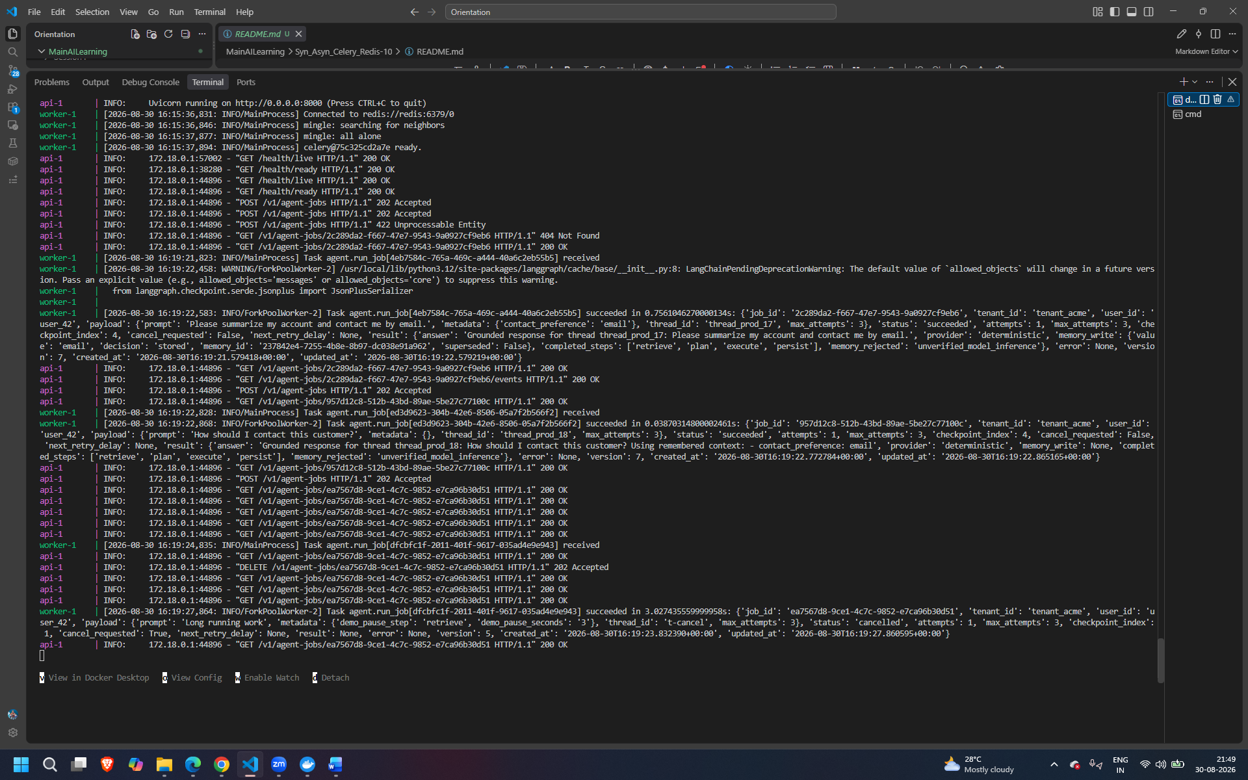
Urls to play around
http://localhost:8000/docs#/
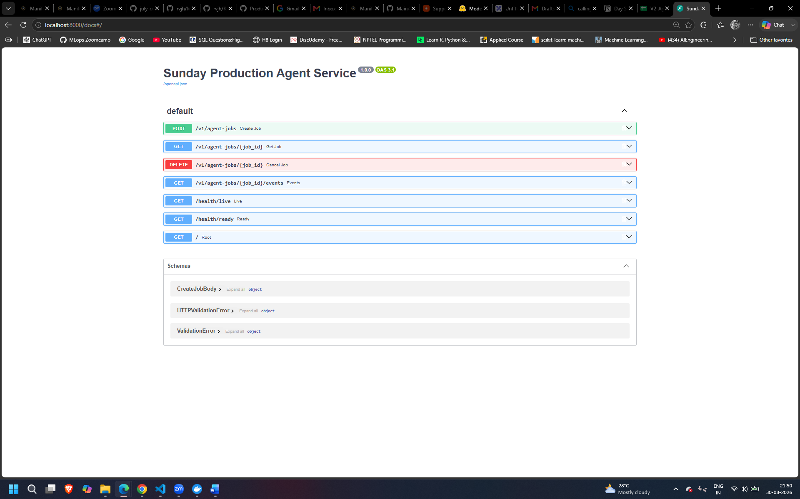
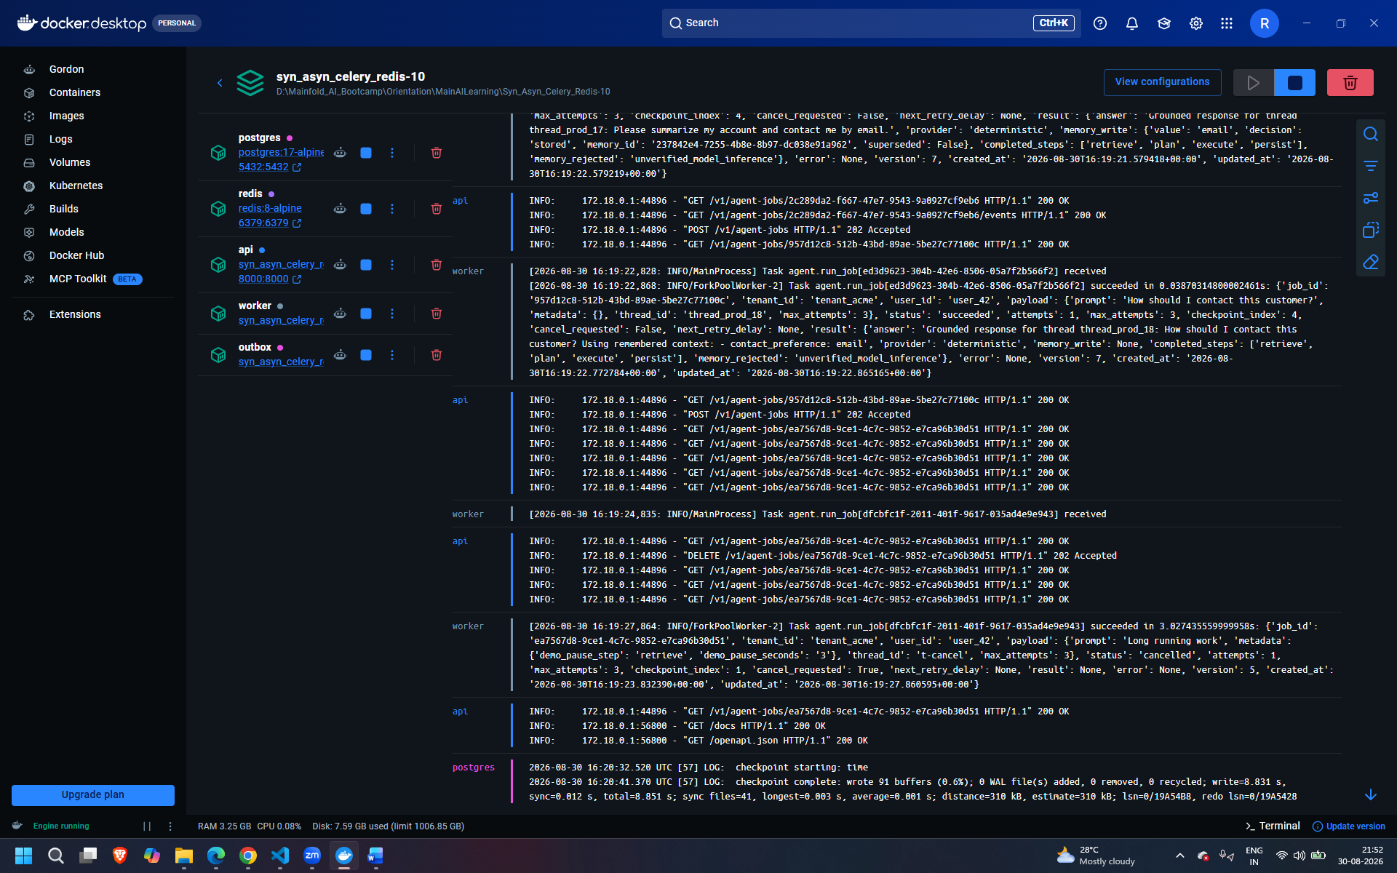

Outbox – kind of todo list
